YORK SOCIETY OF ENGINEERS
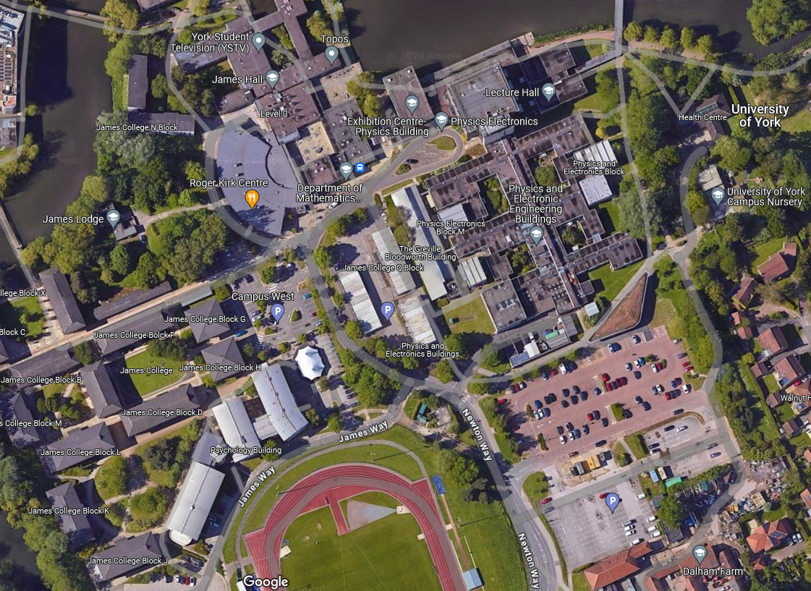
CHANGE of VENUE for the 8th JANUARY LECTURE
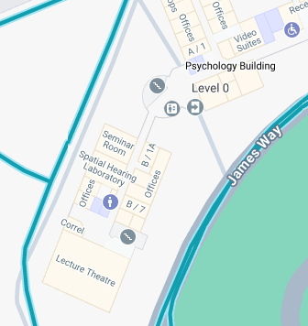
Lectures normally @ P/L/ 001
Enter the Main Entrance to the Psychology Building
(by the Round “Stripped” Tower!)
Once in the building turn left and follow the corridor through block B to the end
5 minute walk
New Venue @ PS/B/020 001

